## Configuring qBittorrent

1 )in advanced options set interface to “isap{GUID}” of OpenVPN interface.

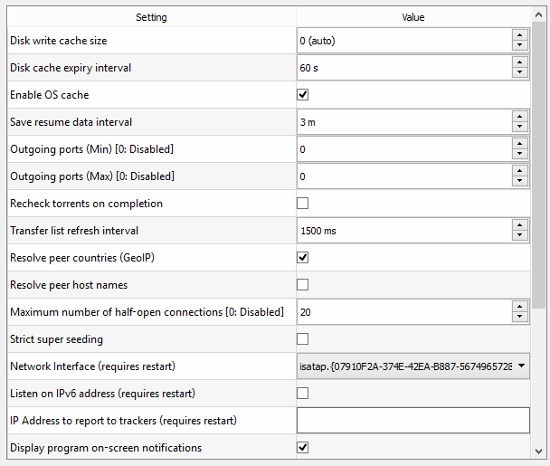

2) in connection disable upnp and use different port on each startup

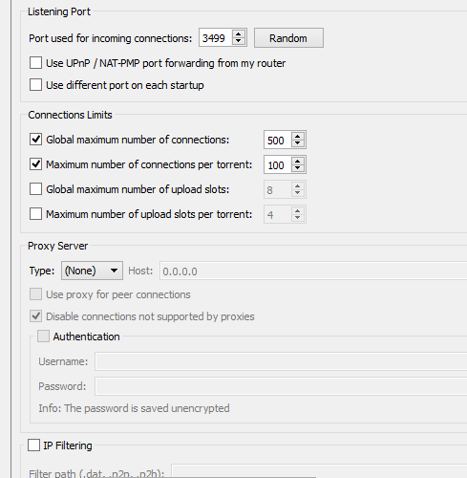

3) in bittorent uncheck enable DHT, Uncheck Enable Peer Exchange, Uncheck Local Peer Discovery

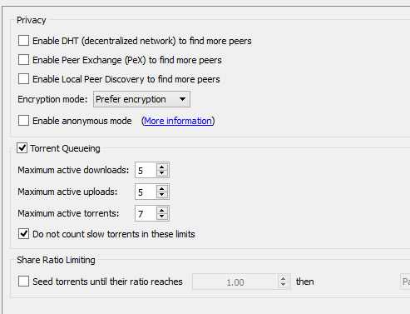

## Configuring Windows Firewall

Run powershell command:

Set-NetFirewallProfile -Name Private -DisabledInterfaceAliases 'Connection Name'

See <https://letitknow.wordpress.com/2012/09/13/manage-windows-firewall-with-powershell-3/> for more examples

**For manual configuration see:**

<https://community.hide.me/tutorials/bind-your-connection-to-vpn-with-windows-firewall.49/>

## Configure Routing Table

Add following to ovpn config connect cmd

@set GATEWAY= 192.168.10.1

route add 0.0.0.0 mask 192.0.0.0 %GATEWAY%

route add 64.0.0.0 mask 192.0.0.0 %GATEWAY%

route add 128.0.0.0 mask 192.0.0.0 %GATEWAY%

route add 192.0.0.0 mask 192.0.0.0 %GATEWAY%

ipconfig /registerdns

ipconfig /flushdns

@pause

Add following to ovpn config disconnect cmd

@set GATEWAY=192.168.10.1

route delete 0.0.0.0 mask 192.0.0.0 %GATEWAY%

route delete 64.0.0.0 mask 192.0.0.0 %GATEWAY%

route delete 128.0.0.0 mask 192.0.0.0 %GATEWAY%

route delete 192.0.0.0 mask 192.0.0.0 %GATEWAY%

ipconfig /registerdns

ipconfig /flushdns

@pause

## Set web browser proxy

~~Download kproxy for chrome:~~

[~~https://chrome.google.com/webstore/detail/kproxy-extension/gdocgbfmddcfnlnpmnghmjicjognhonm~~](https://chrome.google.com/webstore/detail/kproxy-extension/gdocgbfmddcfnlnpmnghmjicjognhonm)

~~Download kproxy for firefox:~~

[~~https://addons.mozilla.org/es/firefox/addon/kproxy-extension/~~](https://addons.mozilla.org/es/firefox/addon/kproxy-extension/)

not sure what to do about this…